USU Student Organic Farm
CSA Program
2022 Season

The mission of the Utah State University Student Organic farm is to provide a healthful, local alternative to grocery store produce while teaching students and the community about the importance of organic farming systems. The USU Organic Farm accomplishes this by educating students through every step of a healthy organic farming system, as well as working together with members of the community to cultivate and distribute fresh quality produce.
About Our Farm The student farm at USU is proud to participate in a Community Supported Agriculture (CSA) program. This means that the farm is run entirely by community support in exchange for our fresh produce. We are dedicated to organic and sustainable agriculture practices that provide our CSA members with a weekly supply of fresh veggies from mid-May until the end of September. We also provide on-the-farm activities and volunteer days to our CSA members so that everyone can learn where their food comes from!
The USU Student Organic Farm is located just South of the intersection at 800 E and 1800 N in North Logan. It is managed and run entirely by students who receive mentoring from Dr. Jennifer Reeve and Dr. Dan Drost. Students, some employed as farm interns, spend their springs planning the season, reviewing farm records, and starting seedlings in the greenhouse. These seedlings are later moved to the farm which is cared for all summer by student interns and volunteers. The student farmers are industrious and hard-working and are committed to providing the CSA members with a wide variety of high quality, fresh, organic produce that represents real value for your money.
Why Join Our Farm?
• Delicious fresh veggies – certified organic, synthetic pesticide and GMO free!
• Know where your food is coming from and who is growing it.

• Receive weekly CSA newsletters including farm news, cooking tips, and recipes for weekly baskets.
• Support student farmers and local, sustainable agriculture.

Shares Our shares come in two sizes, full and half. Half shares provide enough veggies for 2-3 people while full shares will feed approximately 4-6 depending on level of veggie consumption. Shareholders will receive fresh produce weekly beginning May 19th through October 3rd. That’s 20 weeks of locally grown, organic produce! Last year’s CSA members will get priority sign-up and the remaining shares will be available to everyone mid April!

Joint Shares We are partnering with a collection of local vendors to provide our interested shareholders with quality fresh baked bread, fruit, asparagus, cheese, chocolate, honey, and eggs! Find more information on our local vendors and vendor item prices on page 3.

2022 Share Prices
Full Share | $720 | $31/week
Half Share | $420 | $20/week
Membership Ready to become a 2022 CSA member? Complete the form on our website and mail us your first payment!
What to Expect: Listed below is a month‐by‐month outline of the produce our CSA will be offering this season. Start planning some delicious recipes, but also remember that because we are working with the whims of Mother Nature, produce availability is subject to change.
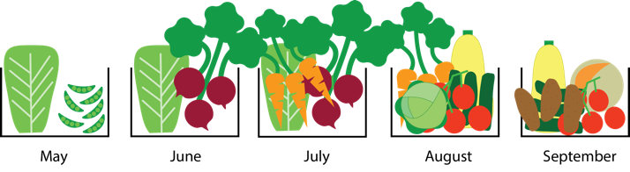

Some things to be aware of:
• Our crops depend on the season and the land; we cannot provide you with all types of veggies at the same time!
• This means warm season crops won’t be available until later in the summer (see list below).
• And expect a lot of cool season crops in the beginning of the season (see list below).
• Feel free to buy a full share and split it with a friend. We won’t be able to package the full share into two shares, but we can give you a couple extra bags if you need them.

Expected produce availability…
May- Salad greens (arugula, red and green lettuce, spinach), radishes, green onions, parsley and cilantro.
June- Salad greens, radishes, green onions, parsley, cilantro, tat soi, mizuna, kale, chard, sugar‐snap peas.
July- Salad greens, green beans, beets, sugar‐ snap peas, summer squashes (zucchini, yellow squash), tomatoes, broccoli, eggplant, peppers (bell and
jalapeno), cucumbers, kohlrabi, garlic, basil, cilantro, and parsley.
August- Summer squashes, green beans, tomatoes, tomatillos, beets, cantaloupe, watermelon, eggplant, kohlrabi, peppers, carrots, beets, garlic, basil, cilantro, and parsley.
September- Salad greens, summer squashes, tomatoes, cantaloupe, eggplant, tomatoes, tomatillos, peppers, winter squash (butternut, spaghetti, pumpkins), potatoes, sweet potatoes, garlic, and parsley
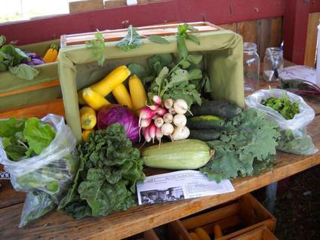
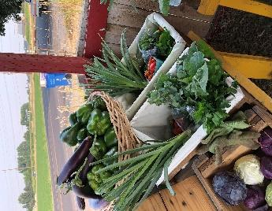
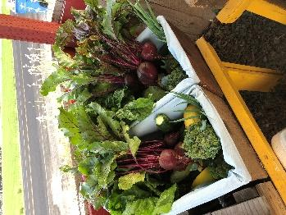
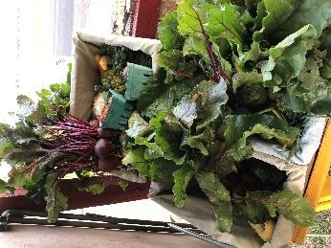

For more information: Email us at organicfarm@aggiemail.usu.edu or visit us at http://usuorganicfarm.weebly.com/

Our 2022 Partnerships
We are excited to announce this year’s partnerships with Zollinger Farm, Aggie Chocolate Factory, Aggie Creamery, Bees Brothers, Crumb Brothers, and Steep Mountain Farm to deliver a bountiful collection of fresh produce, tasty treats, and natural foods conveniently available at our one-stop location! Share prices indicate the price of weekly delivery of product throughout our season.

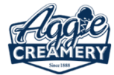
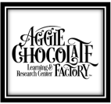
The Aggie Chocolate Factory
The Aggie Chocolate Factory is a student operated organization that crafts bean to bar chocolate. Established in 2018, it is the only student-operated university chocolate factory in the Western United States that primarily serves as a laboratory offering a creative space for food science students to experiment with ideas and flavors. Their sustainably sourced cocoa beans blend social responsibility, sweet reward, and smart returns. By offering Aggie chocolate bars for a great price to our CSA members in 2021, we will provide vital support to our fellow students in their culinary endeavors!
https://aggiechocolatestore.com/
Share prices: 4 bar bundle: , 5 bar bundle:
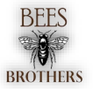
Bee’s Brothers
Bees Brothers is a small, family-operated honey business started as a simple farm project to learn more about beekeeping. Soon the abundance filled countless jars with sweet, extra thick honey that created quite the buzz at the Cache Valley Farmers Market. To keep up with the busy bees, new ideas for honey products arose. They now specialize in delightful honey caramels that come in a variety of flavors! We are partnering with Bees Brothers to offer their caramels, honey and even honey roasted almonds to our CSA members! https://beesbrothers.com
Share Prices: 12oz honey: $35, honey caramels: $35, Honey almonds: $40, All three: $105
The Aggie Creamery
The Aggie Creamery is best known for their staple Aggie Ice Cream, which was created in 1921 by USU’s Dairy Department in the College of Agriculture. The creamery serves many purposes by giving students hands-on dairy processing experience as well as providing a head start in their career fields after graduation. Although we will not be offering Aggie Ice Cream through our CSA, we will offer an assortment of cheeses, such as their famous Aggiano, Old Ephraim, and Crimson Trail. These will be available to our CSA members from the Aggie Creamery, and we look forward to working with them this year! https://aggieicecream.usu.edu
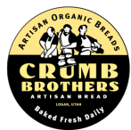
Share prices: Old Juniper: $65, Aggiano: $65, Pepper Jack: $65, Old Ephriam: $65, Crimson Trail: $60, Rotation of cheeses: $62

Crumb Brothers
Cache Valley’s very own Crumb Brothers Bakery & Cafe is our final partner we would like to note with their fresh baked, artisan breads. This local wholesale/retail bakery offers an array of the finest breads and pastries. They serve our community by offering jobs and a delightful place to share breakfast, brunch or lunch with family or friends in a charming atmosphere! We are honored to partner with them and offer our CSA members the option to purchase their breads along with our produce and excellent products from our other vendors! https://crumb-brothers.square.site/
Share Price: $130 for 1 loaf/week

Steep Mountain Farm
Steep Mountain Farm is a local regenerative agriculture project which hand tends their flock and values quality and care above cost. Hens range on open rotated pastures and are fed certified organic feed. We’ve partnered with Steep Mountain Farm to offer eggs on-demand during our weekly pickups.

Zollinger Farm
In 1904, William Zollinger purchased and planted the land where Zollinger Farm now sits. Their farm has been family owned and operated for almost 120 years. Over the last several decades, Zollinger Farm has provided Cache Valley with quality fruit and vegetables, in addition to landscaping trees. Zollinger Farm will be supplying this year’s asparagus and fruit supplies.
Share Prices: Fruit: $250 for 1 lb/ week, Asparagus: $24 per bundle

